Tender’s Healthy Relationship Education in Schools funded by Comic Relief

Final Evaluation
Summary Report

DMSS Research & Consultancy
www.dmss.co.uk

September 2012

Introduction
Tender has developed an educational model using drama and the arts to:
  - Enable young people to develop positive attitudes towards relationships in order to prevent violence against women and girls.
  - Equip adults with the skills and resources they need to promote healthy relationships amongst young people.
In 2010, Tender obtained funding from Comic Relief to carry out a two year project to work in eight London secondary schools, explicitly taking a ‘whole school’ approach. The aim was to embed violence prevention in the curriculum and in school policies, as well as providing staff and young people with the knowledge and confidence to tackle gender-based violence and promote healthy relationships.
In September 2010, Tender commissioned DMSS Research to conduct an evaluation in order to assess the success of the project in helping schools achieve a whole school approach to violence prevention and to identify lessons that might have wider application.
Data was collected through:
- Interviews with the lead teachers in each school;
- Interviews with Tender facilitators working on the Comic Relief funded project;
- Group interviews with young people;
- Observation of project delivery in each school;
- Before and after questionnaires completed by young people and teachers.

The eight schools participating in the project were:
- Dunraven (Lambeth)
- Beal (Redbridge)
- Hendon (Barnet)
- Marshalls Park (Havering)
- Parliament Hill (Camden)
- Southgate (Enfield)
- Thomas More (Croydon)
- Winchmore (Enfield)

In our initial interviews with lead teachers from each school we explored their motivations for getting involved in the project, why healthy relationships was a priority for them, what they were already doing to address the issue and what they hoped to achieve through the work with Tender.
The main reasons for schools wanting to participate in the programme were:
- Previous positive involvement with Tender;
- The personal commitment of the lead teacher to tackling gender based violence;
- Recognition of the relevance of the issues to their young people and the impact of sexual bullying and unhealthy relationships on their students.
Tender’s approach particularly appealed to the schools because of their use of drama, their specialist expertise on the issues and their collaborative and flexible approach to working with school. Lead teachers also welcomed the concept of using a peer education model and the emphasis on sustainability beyond the time-frame of the project.
“The emphasis is on the long term. Our head is very keen on sustainable projects, working so that there is a long term impact. Tender offers a model of training to our students so that they can pick up the issue once Tender has left”.
Lead teachers recognised that the knowledge and confidence of teachers in dealing with relationships issues was very variable. Training for staff was therefore identified as a potentially valuable part of the programme.
Although lead teachers gave examples of how healthy relationships were already addressed in the curriculum and in some school policies most agreed that the issues were not approached in a very systematic way.
There was considerable consistency between the schools on what they hoped to achieve from participation in the project. The main anticipated outcomes were:
- Increased staff awareness and confidence
- Increased awareness of healthy relationships among students
- A healthier school culture
- Value for staff and students from working with external experts
- Students gaining specific skills
- Raising a positive profile for the school

Achieving a whole school approach
The diagram overleaf represents the key elements of Tender’s whole school approach. The evaluation sought to assess the extent to which the project has helped schools to address each of these.

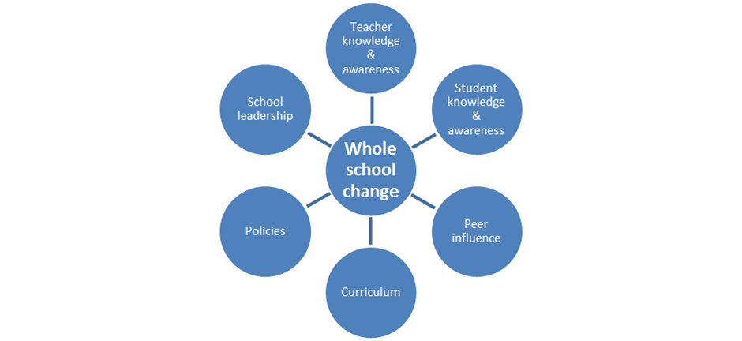

Student knowledge and awareness
Questionnaire responses suggest that a considerable number of students knew about violence and abuse in relationships from direct experience. While only very small numbers said they had been pressured into having sex, pressured into getting married or threatened if they didn’t do something their partner wanted, 30% of young people said they’d been yelled loudly at, 28% put down or humiliated and 16% hit, kicked or pushed. 12% had been constantly checked up on.

Pre and post questionnaire responses indicate that participation in Tender workshops increases young people’s knowledge and awareness. For example, the percentage of those agreeing with the statement: ‘Abuse in relationships is a problem affecting only a small number of people’ fell from 20% to just 3% and the percentage agreeing with the statement ‘A women is more likely to be raped by a stranger than someone she knows’ fell from 40% to 17%.
A large majority of young people reported that they had more understanding of healthy/unhealthy relationships (94%), felt more confident in dealing with sexual bullying (76%) and had more knowledge about sources of support (89%) as a result of attending Tender workshops.
Towards the end of year two the views of young people were gathered through group interviews conducted in six of the eight schools. All the young people remembered the work with Tender and were able to provide an explanation of what the work was about, sometimes in considerable detail. However, the level of recall depended greatly on three factors:
- ‘Dosage’ – how intensively they had been involved with Tender’s work in their school;
- Distance – how much time had passed since the intervention;
- Age – older participants recalled more accurate information about the project and its purpose.

“Before, I thought that domestic violence was ‘out there’ – something unfortunate that happens to a few couples. But I realise now how common it is. It is imprinted on my mind now. The early warning signs were a new thought to me”.
In general, older young people who had been involved with the project for several sessions remembered more about what they had learned. They were also more likely to comment on their personal and skills development as well as their learning.
“I haven’t been in a relationship yet but I think now I have thought more about what I would be looking for and hoping for. There is always that uncertainty about what you want but I think I am more aware now.”

Drama students who had worked on a production with Tender also commented on the way the project had ‘helped their drama.’

All the lead teachers thought that young people had increased their understanding of violence and abuse in relationships and made comments on the increased depth of understanding. They provided many examples of positive achievements for particular groups.

“All eight who took that unit (as part of A Level drama) got distinctions and had the most incredible experience. I think there were several levels of impact – the message about healthy relationships, the impact it had on the quality of their drama. The issue was so emotive and so important that it made their drama better.”

Developing peer influence
The development of young people as peer educators and advocates of healthy relationships was pursued in a variety of ways in the different schools. A couple of schools were keen to develop a group of young people as ‘ambassadors’ or ‘relationship advisors’ to peer mentor other young people. Others developed drama presentations or DVDs by students to be delivered to other young people in assemblies and to other schools. A key lesson from the project is that such developments take time and there can be some difficult ‘juggling’ to fit around competing demands within schools. Nevertheless, by the end of year two, there were examples of peer education or mentoring in most of the schools, including presentations to other students and parents, student-led workshops and lesson planning.
As well as formal peer education, interviews with young people highlighted examples of peer support to friends.
“My friend was in a relationship without much trust and after Tender I felt ‘ if you are not enjoying the relationship you might as well get out before everything becomes too serious’ She and I talked a lot. ..She got a lot out of it, and I thought this is what Tender has taught me. She got out of the relationship, moved on and I was really happy for her.”
Teachers’ knowledge and awareness
Most of the training to staff in schools was delivered during year two of the project and there was considerable praise for the quality of the training - whether at whole staff meetings or twilight sessions for smaller groups. All lead teachers reported that it had impacted on the confidence of those attending to address relationship issues. The extent of this impact varied from school to school as different schools had used the training on offer to different degrees and for different purposes. It is often difficult to reach whole staff groups because of competition for those training slots, but lead teachers gave many examples of the benefits to particular groups, such as pastoral teams. These included building confidence to tackle the issues and the development of a network of staff within the school and beyond.

“Tender’s approach has given me a vocabulary, a way of approaching this. I feel I have some new skills, some new resources and more sense of a network of other staff and schools tackling this issue too”.
Integration into school policies and curriculum
By the end of year two, our interviews with lead teachers suggest that progress has been made towards integrating healthy relationship issues across the curriculum with a couple of the schools becoming particularly advanced.

The project appears to have had less impact on school policies, perhaps because this is an area which is more difficult for an external agency to influence. Only one school reported having reviewed/rewritten policies during the course of the project. One lead teacher said that this was because their policies were under constant review and were already very good. All the others said that this was work still to be done but that it was ‘on the agenda’.
However, although formal policy may not have been revised, some lead teachers reported changes in the practice of their school – and of teachers – that they believed to be a direct outcome of the project as a ‘whole school’ project.

Leadership and sustainability
All eight lead teachers were able to describe plans for sustaining the project in the next academic year. The schools with the most developed plans included further staff training, the expansion of healthy relationship education into different year groups and various peer education developments.

Two teachers were very confident of being able to sustain work on healthy relationships into the future. However, a number recognized the challenge of sustaining such work and how much its future depended on them as individuals. It was suggested that in order to be sustained the ‘healthy relationships’ issue needs to have a senior champion in the school. Energy and enthusiasm from a more junior ‘champion’ can take the issue so far but a whole-school approach needs leadership at a senior level.
The value of an ongoing relationship with an external body like Tender was also recognised.

“We are really moving forward on our own now. But Tender has done a huge amount to help us get started and to build our skills and confidence.”

The ingredients of success
The factors that emerge from the evaluation as the main ingredients of success are:

The commitment of participating schools: Leadership in the form of a passionate lead teacher, combined with a supportive Head, seems to be the most important factor in getting and maintaining commitment. A shared understanding of what it means to take a whole school approach to issues of healthy relationships and gender equality also seems to have been important to the success of the project. A key element of sustaining schools’ commitment has been Tender’s flexibility of approach in tailoring their work to meet schools’ individual needs.

The quality of Tender’s work: A very important part of maintaining engagement is the continuing recognition of Tender as a valued organisation bringing specialist expertise and skills into the schools. Tender was very much valued by lead teachers for their expertise on the issues of healthy relationships, violence and abuse alongside the workshop leaders’ highly skilled use of drama and their ways of engaging with young people and staff. The skills of Tender facilitators, their ability to establish relationships with teachers and their responsiveness to the needs of schools were all highly valued.

“I think [the Tender facilitators] coming in here, they are just great. They are the sort of people that are suitable for this environment. ..They are fantastic…”
Planning and communication: Delivering a project using a variety of facilitators in collaboration with eight different schools entails some obvious logistical challenges. Year one of the project offered some lessons about the importance of planning and ongoing communication. By the end of year two any early difficulties seemed to have been resolved and there was praise from many of the lead teachers for the overall co-ordination and management of the work, and particularly the responsive and collaborative nature of the relationship with Tender. Competing priorities and staff workloads are inevitable challenges when working with schools.
The engagement of young people: The ability of the project to engage young people is clearly a key element of its success. Observations indicated that workshop leaders were very successful in engaging young people, even when groups were more challenging in terms of size or behaviour. Engagement seemed to vary according to whether young people had volunteered or not, the size of the groups, age and gender balance. The selection of young people to be involved in the project was not always within Tender’s control and inevitably this resulted in Tender facilitators sometimes working with groups that were too large, too small or less able to engage with the work. Mostly, Tender facilitators were extremely agile and flexible in their ability to respond to whatever groups they were presented with.
The value of a drama-based approach: Tender’s use of drama was highlighted as a key ingredient of the project by both teachers and young people. Drama was described as a way of promoting engagement, bringing life and energy to a topic, empathy with the experience of others and self-expression. These ‘four E’s’ of engagement, energy, empathy and expression were frequently referred to in interviews with teachers and young people alike.
“I think drama is good because you can really feel how things are. If you just read off a sheet, you can think ‘Oh yes, that happens…’ but if you are acting it out it feels different. And I think you would recognize it more if you were ever in that situation yourself. Things get to you more through drama.”

Conclusion
The overall conclusion of this evaluation is that Tender’s ‘whole school’ approach to challenging gender based violence and promoting healthy relationships can be successfully implemented in schools. The Comic Relief funded project has tested the theory of change and our findings suggest that the model is effective - with all eight participating schools implementing most of the core elements of a whole-school approach within the funding period.
The evaluation also highlights that successful implementation is dependent on the efficacy of Tender’s direct work with young people and staff, flexibility in adapting interventions to meet the needs of individual schools, combined with strong leadership and commitment on the part of collaborating schools.

Acknowledgements: Tender and DMSS Research would like to thank the staff and students of participating schools for their time and commitment to this evaluation.

